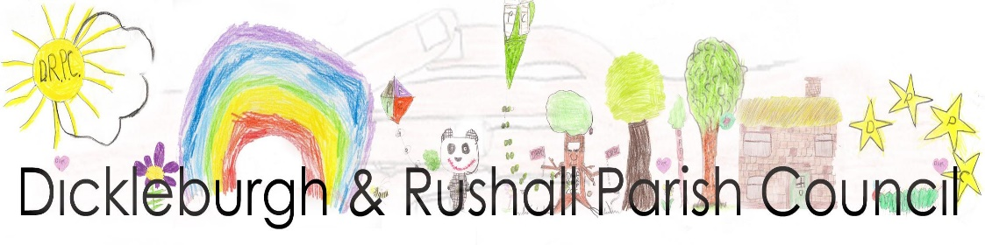
Dear Councillor

I hereby summon you to the Meeting of the Parish Council, at Dickleburgh & Rushall Village Centre to be held on Monday 13th January 2025 at 7.00pm

Ann Baker, Clerk to the Council 6th January 2025

AGENDA
Members of the Public are welcome to the meeting. At the start of the meeting fifteen minutes will be available to members of the public to make comments on matters listed on this agenda which may help the councillors with their decision making process.

- To consider accepting apologies for absence
- To receive & update any declarations of pecuniary & other interests from members on any item to be discussed
- Adjournment of the meeting for Public participation, County & Dist. Cllrs. reports
- To receive a presentation from Mr. B. Grief, Forestry Commission & discuss possible Parish Council responses or actions
- To approve the minutes of the meeting held on 9th December 2024
- To note matters arising from the minutes of the last meeting – for information purposes only:
- Update on the website & domain changes (min. 103b)
- Information sent to the Highways Rangers (min. 103c)
- Information on the cost of signage for Furze Green (min. 103d)
- Update on details for the safe crossing on the car park & markings (min.103f)
- Update on the additions to the play area (min.103g)
- Town Lands Trust update (min.103h)
- Planning Application Waveney Valley Holiday Park (min. 110a) – neither actions taken due to receipt of new application
- Street lighting
- To receive the Monthly Financial Report from the RFO including notification of payments made over the last month & take any necessary actions:
- To approve the payments & receipts
- Bank Reconciliation – third quarter report
- Update re return of the Precept & Budget for 2025/26 figures to SNC
- Update on the request from St. Edmundsbury Academy to support a Dickleburgh child on various school trips & to take any actions
- To consider further advice from the Village Centre management Committee regarding the trustees of the Village Centre & take any actions
- To receive an update on the lighting, the new doors & the survey for a heat pump at the VC & to take any necessary actions
- To receive an update on the National Planning Policy Framework (NPPF) changes with regard to the Dickleburgh & Rushall Neighbourhood Plan (DRNP) & action taken
- Planning Applications as received from South Norfolk Council incl.:
- Planning Application 2024/3439 Lawful Development - proposed use/dev. Waveney Valley Holiday Park, Air Station lane, Rushall – the proposed use of land within the existing holiday park for the siting of static caravans without restriction on the layout of the caravans (up to a max. no. of 71)
- Planning Application 2025/0029 Upper Vaunces Farm, Semere Lane, Pulham St. Mary – 2 x no. extension to existing 8 no. shed poultry production facility
- To consider any applications which may have been received prior to the meeting & of which Councillors have been previously advised
- To receive consultees reports of planning decisions made by SNBC
- Highways & PROW reports & to take any necessary actions:
- update on replacement road signage - Semere Green Lane, Beech Way, Upper Tumbril Lane
- Information received from ‘Transport made Simple’ regarding service 84 & take any necessary actions
PRoW: update on: PROW 3 ownership & maintenance; Green Lane, Rushall
- Playing Field reports & take any necessary actions:
- To note receipt of the monthly play area inspections
- Update on the Playing Field hedge cutting (min. 112b)
- Update on a solar powered light at the edge of the entrance to the car park & take any necessary action (min. 112c)
- To receive an update removal of the dog bin from St. Clements Common to the Church grounds & take any actions
- To receive matters of information from Councillors
- To receive items for the next agenda

The press and public are invited to attend the meeting

Please contact Clerk to the Council, Ann Baker 01379 742937 or email: clerk@dickleburghandrushallpc.org.uk

