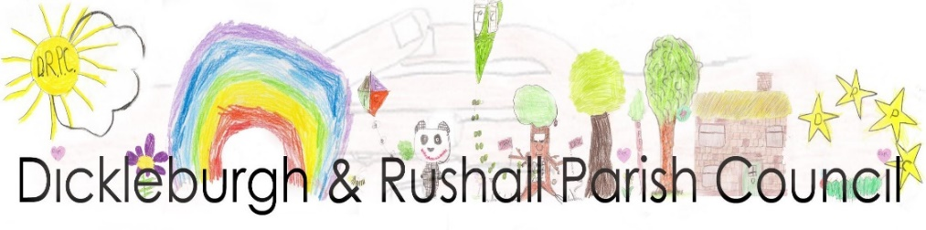

Dear Councillor,

I hereby summon you to the Parish Council Meeting, at St. Mary’s Church, Rushall to be held on Monday 8th June 2026 at 7.00pm

Ann Baker, Clerk to the Council 3rd June 2026

AGENDA
Members of the Public are welcome to the meeting. At the start of the meeting fifteen minutes will be available to members of the public to make comments on matters listed on this agenda which may help the councillors with their decision making process.

- To consider accepting apologies for absence
- To receive & update any declarations of pecuniary & other interests from members on any item to be discussed
- Adjournment of the meeting for Public participation, County & Dist. Cllrs. reports
- To approve the minutes of the meeting held on 11th May 2026
- To note matters arising from the minutes of the last meeting – for information purposes only:
- Update on the bus shelter (min.23a)
- Progress on the Furze Green gateway signs (min.23b)
- Update on Regener8 – Semere Green Solar Farm (min. 23c)
- Common’s Committee – new members update (min. 23d)
- Update on the trustees/lease discussions with the Village Centre (min.23e)
- Defibrillator battery – update
- Update on regular litter picks
- To receive the Monthly Financial Report from the RFO including notification of payments made over the last month & take any necessary actions:
- To approve the payments & receipts
- To approve the Annual Internal Audit Report 2025/26 from Mr. R. Goreham
- Approval of the AGAR Section 2 – Accounting statements 2025/26
- Approval of the dates of the period for the exercise of Public Rights - 22nd June to 31st July 2026
- To approve an item from the Standing Orders - payments made by BACs/Faster Payments bi-annually
- To approve the Regular Payments list for 2026/27
- Digital & Data Compliance AGAR Assertion 10: Data Protection, I. T. policy (b) to confirm the action plan for the internal/external auditor
- To review & confirm the Roles & Responsibilities paper
- To receive short reports from the following Working Parties & take any necessary actions: (a) DRVC report (b) Recommendation the Grants Working Party re an amendment to conditions (c) Allotments on Norwich Rd (d) Community Facilities grant application update
- To approve: Freedom of Information policy, General Data policy, LGA Code of Conduct
- To consider: (i) information re the lay-by on The Street for bus passengers & a possible remedy (ii) bus shelter grant application update
- Planning Applications as received from South Norfolk Council incl.:
- Planning Application 2026/1202 18 Millers Drive, D’burgh – demolition of fire damaged dwelling and erection of a replacement single dwelling, including associated works and a single semi-detached garage
- 2026/1101 Rose Cottage, Norwich Rd., D’burgh Repair roof, renew facias, sofits, guttering, replace windows and front & side doors.
- Half Moon update
- To consider any applications which may have been received prior to the meeting & of which Councillors have been previously advised
- To receive consultees reports of planning decisions made by SNBC
- Highways & PROW reports & to take any necessary actions:
- Highways matters – drain cover on The Street - update b. PROW matters
- Playing Field reports & take any necessary actions:
- To note receipt of the monthly play area inspections
- To receive an update on the inflatable on the Playing Field
- To consider amendments to the agreement of the Playing Field with D’burgh FC
- Request from Mikeys Bar to hold their Charity Funday event on Sat. 25th July
- To consider arrangements for the Village Festival on Sat. 27th June 2026
- Information to note: (a) South Norfolk Council confirmation that Neighbourhood Plan forms part of the statutory development plan for SN (b) A letter from the County NALC Officer (c) East Anglian Air Ambulance appeal (d) email for recycling bank on VC site or bottlebank site
- To receive matters of information from Councillors
- To confirm the date of the next meeting & receive items for the next agenda

The press and public are invited to attend the meeting

Please contact Clerk to the Council, Ann Baker 01379 742937 or email: clerk@dickleburghandrushallparishcouncil.gov.uk

